Alex Arnold

Professor Torres

45/15/25

IT 0115-41197

Lab 11

Part A: Windows (Netlabve3Links to an external site.-->70-740 Lab 01 Justice Domain Controller)

Perform the below actions against the systems:

Rename DCB to Justice and Promote to the Domain Controller

Demote DCA and rename Marvel and join to the Justice DC

Join Windows 10-PCA and Windows 10-PCB to the Justice Domain



Continue to part B

Part B: Windows (Netlabve3-->70-740 Lab01 Justice Domain Controller)

Try to answer the below via "command line or PowerShell":

Find all pdf's in a system

Find all xlsx's in a system

List the top running processes in the system

List the routing table

List the IP addresses

List logged-on users



List file/folder permissions for a document "any document"

List permissions for an application "any application"

List the firewall rules (private, public, and domain)

Part C: Linux

Access the Over The Wire website (Links to an external site.)

Use Putty (Links to an external site.) or SSH via Linux to access the Over the Wire lab area

Complete Lab 11-30. On each completed task add the below line

echo "your name"

Lab 11

Lab 12

Lab 13

Lab 14

Lab 15

Lab 16

Lab 17

Lab 18

Lab 19

Lab 20

Lab 21

Lab 22

Lab 23

Lab 24

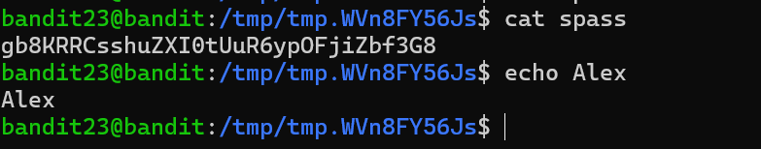

Lab 25

Lab 26

Lab 27

Lab 28

Lab 29

Lab 30

Extra credit: Automate Part B

# --- Find all PDFs in the system ---

Write-Output "`n--- All PDF Files ---`n"

Get-ChildItem -Path C:\ -Recurse -Include *.pdf -ErrorAction SilentlyContinue | Select-Object FullName

# --- Find all XLSX files in the system ---

Write-Output "`n--- All XLSX Files ---`n"

Get-ChildItem -Path C:\ -Recurse -Include *.xlsx -ErrorAction SilentlyContinue | Select-Object FullName

# --- List Top Running Processes ---

Write-Output "`n--- Top Running Processes by CPU Usage ---`n"

Get-Process | Sort-Object CPU -Descending | Select-Object -First 10 Name, Id, CPU

# --- List Routing Table ---

Write-Output "`n--- Routing Table ---`n"

route print

# --- List IP Addresses ---

Write-Output "`n--- IP Addresses ---`n"

Get-NetIPAddress | Select-Object IPAddress, InterfaceAlias, AddressFamily

# --- List Logged-On Users ---

Write-Output "`n--- Logged-On Users ---`n"

query user

# --- List File/Folder Permissions for Any Document ---

$documentPath = "C:\Users\Public\Documents\Sample.docx" # Change path if needed

Write-Output "`n--- Permissions for Document: $documentPath ---`n"

if (Test-Path $documentPath) {

Get-Acl $documentPath | Format-List

} else {

Write-Output "Document not found at $documentPath"

}

# --- List Permissions for an Application Folder ---

$appPath = "C:\Program Files\Google\Chrome\Application" # Change path if needed

Write-Output "`n--- Permissions for Application Path: $appPath ---`n"

if (Test-Path $appPath) {

Get-Acl $appPath | Format-List

} else {

Write-Output "Application path not found at $appPath"

}

# --- List Firewall Rules by Profile (Domain, Private, Public) ---

Write-Output "`n--- Firewall Rules by Profile ---`n"

@("Domain", "Private", "Public") | ForEach-Object {

Write-Output "`n--- $_ Profile Rules ---"

Get-NetFirewallRule -PolicyStore ActiveStore | Where-Object {

($_.Profile -like "*$_*")

} | Select-Object DisplayName, Enabled, Direction, Action, Profile

}